1. **IT in Automobile** Information technology has really revolutionized the car industry, equipping vehicles with intelligence, making them safer and more efficient. Let's have a look at how this has come about:

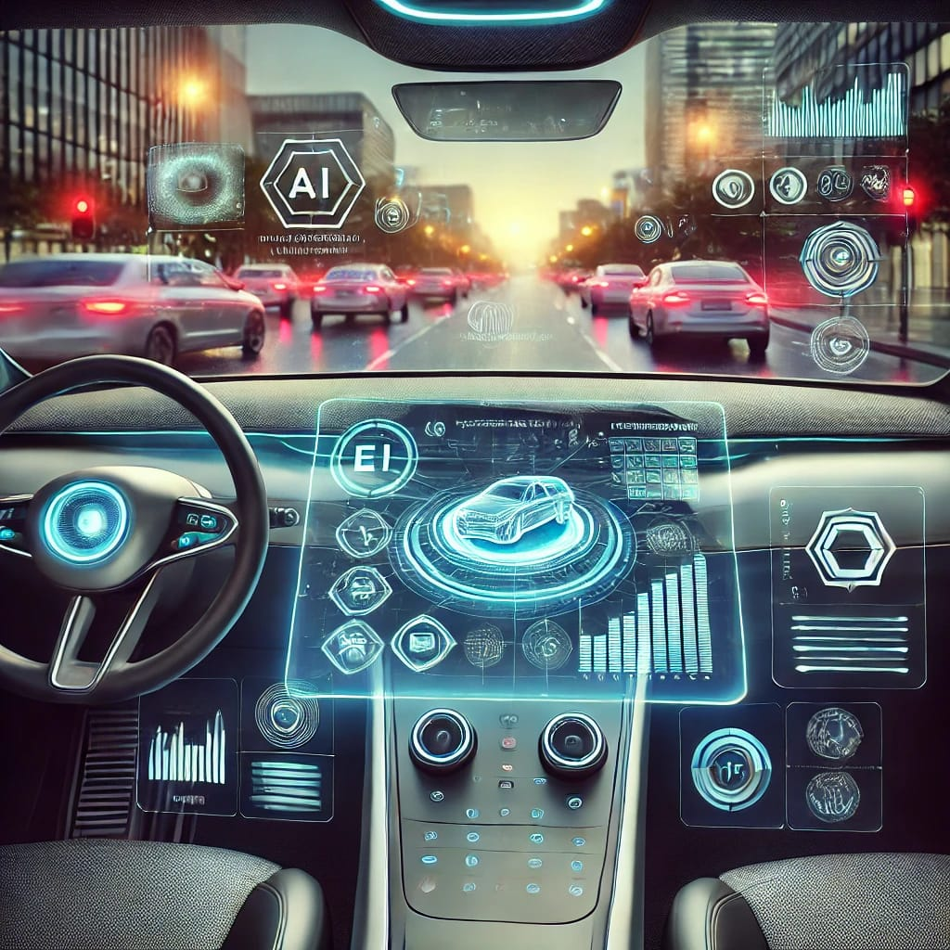  
  
**Introduction:**  
The automotive sector is witnessing a gigantic change, and Information Technology (IT) is at the center of this revolution. From autonomous vehicles to sophisticated infotainment systems, the auto sector has adopted IT in ways that were unimaginable a few years ago.

**Main Body:**

Information Technology in vehicles has filled the gap between electronics and mechanics, allowing for the creation of intelligent, efficient vehicles. With the use of sensors, software, and artificial intelligence (AI), IT has improved safety, performance, and driving experience.

**1.Autonomous Vehicles**

When we hear the term "self-driving car," we don't have to think about science fiction anymore. Indeed, it's projected that by 2035, autonomous cars may be bringing in as much as 1.3 trillion in revenue worldwide. Leading the way are companies such as Tesla, with their Autopilot and Full Self-Driving capabilities, which keep getting smarter. And by 2025, we can expect more than 10 million autonomous vehicles on the road, revolutionizing how we view driving to work.

**2.Connected Cars**

Picture a car that converses with traffic lights and notifies you of future dangers. That's the strength of connected vehicles, which will total more than 400 million worldwide by 2023. Thanks to the new 5G, they'll be even faster at chatting with other vehicles and infrastructure, preventing accidents and minimizing traffic. Ford puts this figure at reducing accidents by as much as 80%.

**3.Electric Vehicles (EVs)**

The rise of electric vehicles is no longer a trend, it's the future. In 2022, global sales of EVs skyrocketed to 10.5 million units—a massive 55% increase from the previous year. Tesla continues to dominate the market, holding around 17% of global sales, but other automakers are catching up. The shift toward EVs could help us reach net-zero emissions goals and reduce our reliance on fossil fuels.

**4.Smart Manufacturing**

Behind the scenes, technology is also transforming car manufacturing. From robotics and 3D printing to sophisticated AI in the factory, firms are cutting production time and expense. Indeed, Deloitte estimates that automakers are investing billions of dollars a year on digital technology to accelerate production and decrease errors. Smart manufacturing systems are enabling companies such as Ford and General Motors to make more cars in less time with less error.

**Safety:**

One of the most important breakthroughs is in car safety. Features such as Automatic Emergency Braking (AEB), Adaptive Cruise Control (ACC), and Lane-Keeping Assist are dependent on sensors, cameras, and artificial intelligence, preventing accidents and ensuring safer driving. These features read real-time information to support or even take charge of the vehicle in hazardous conditions, basically serving as a second set of eyes for the driver.

**Conclusion:**

The future of cars is certainly IT-driven. With technology advancing further, we can expect even more innovations like self-driving cars, more intelligent AI systems, and cars that can talk to other cars and infrastructure. It's certain that the union of IT and cars is not a fad—it's the future.

**2. IT in Metro Rail**

When we think about metro rail systems, they’re not just about getting from one point to another anymore—it's about making commuting smoother, safer, and more efficient with the help of IT.

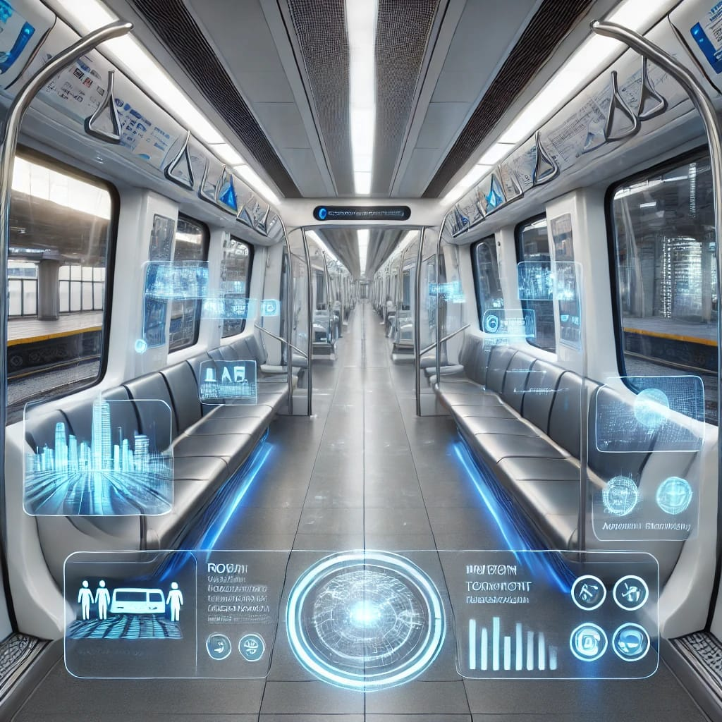

**Introduction:**Metros have become the backbone of urban transportation, and Information Technology has revolutionized how metro systems operate, ensuring they are safe, efficient, and customer-centric.

**Main Body:**The role of IT in metro rail systems goes beyond just ticketing and scheduling. It integrates everything from train operations to maintenance, creating a seamless experience for passengers**.**

**1.Automated Train Operations (ATO)**Cities like London and Dubai are already operating metro lines with Automated Train Control (ATC). In Dubai, the metro is fully automated, running 24/7 without human drivers. It's no surprise that more cities are adopting this technology, as it leads to fewer delays and more efficient train schedules.

**2.Smart Ticketing**Forget long queues at ticket counters. In places like London, contactless payment systems like the Oyster Card have become the norm, with 50% of journeys now paid for via contactless methods. New York City is following suit with its OMNY system, allowing passengers to simply tap their smartphones to enter and exit stations.

**3.Predictive Maintenance**Imagine being able to fix problems before they happen. That’s what predictive maintenance is all about. In Singapore, metro systems use IoT sensors to monitor the health of trains and tracks. This data helps identify potential failures before they cause delays, cutting maintenance costs by up to 25%.

**4.Real-Time Passenger Information**Real-time information is a game-changer for passengers. Systems like the ones used in Delhi Metro or Mumbai Metro give commuters live updates on train arrival times, disruptions, and delays. This makes the whole experience more predictable and stress-free.

**Train Operations & Safety:**IT is integral in the operation of metro trains. Advanced signaling systems, train control, and communication networks ensure that trains run on time and are safely spaced apart, preventing accidents. Automatic Train Operation (ATO) systems are now becoming common, allowing for more precise control of train movement and reducing the chances of human error.

**Passenger Experience:**The use of digital displays, Wi-Fi services, and mobile notifications has significantly improved the passenger experience. Not only do passengers get real-time information on train arrivals, but they can also access services, track delays, or plan alternative routes if necessary—all through apps.

**Conclusion:**In the near future, IT is likely to take metro rail systems to new heights with developments such as driverless trains, more personalized travel experiences, and the integration of artificial intelligence to optimize every aspect of the service. The impact of IT on metro systems is profound, making them safer, smarter, and more efficient than ever before.

**3. IT in Avionics**

In aviation, IT isn’t just helping with flight efficiency; it’s improving safety and the overall passenger experience in ways we never imagined just a few decades ago.

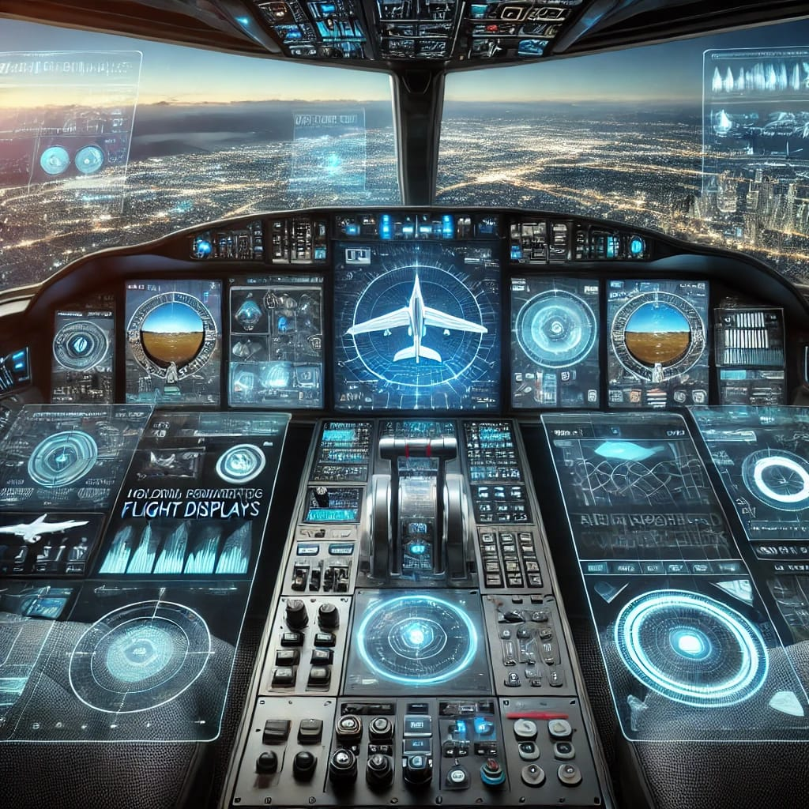

**Introduction:**  
Avionics—the electronic systems used in aircraft—have evolved dramatically with the help of Information Technology. From enhancing safety to improving operational efficiency, IT has transformed how airplanes fly, communicate, and navigate.

**Main Body:**  
Avionics is no longer just about navigation and communication systems; it now encompasses everything from flight control systems to in-flight entertainment and maintenance diagnostics.

**1.Flight Control Systems**Today’s aircraft, like the Boeing 787 and Airbus A350, rely on fly-by-wire technology. This means that flight surfaces are controlled digitally by computers rather than mechanical systems. The benefit? It makes flights smoother and allows for real-time adjustments to keep the plane stable in turbulent conditions.

**2.Navigation & Communication Systems**  
Gone are the days of paper maps and relying on visual landmarks. Modern aircraft use satellite-based navigation systems like GPS to plot the most efficient flight paths. This can save airlines billions in fuel costs. For example, airlines could save up to 5 billion annually on fuel by using these more efficient routes.

**3.Aircraft Health Monitoring**  
The ability to monitor an aircraft's health in real-time is crucial. With sensors embedded in key parts of the plane, airlines can predict maintenance needs and prevent major failures. This type of monitoring has already saved airlines like Delta about 10% in maintenance costs and reduced unscheduled downtime.

**4.In-Flight Entertainment (IFE)**For passengers, in-flight entertainment (IFE) systems have come a long way. Emirates offers over 4,500 channels of entertainment, from movies to music, and is even testing 5G in-flight internet for faster streaming. This is part of a broader trend of using IT to enhance the flying experience, providing passengers with more comfort and connectivity during their journeys.

**5.Safety and Collision Avoidance**  
In the sky, safety is paramount. Collision avoidance systems, powered by IT, are now standard in aircraft, warning pilots of nearby aircraft and even taking evasive action automatically if needed. According to FAA data, systems like TCAS (Traffic Collision Avoidance System) have been instrumental in reducing mid-air collision incidents by 90%

**Conclusion:**  
The aviation industry’s future lies in the continued integration of IT. With advancements such as more efficient flight routes, improved real-time data systems, and innovations like drone technology, IT in avionics will continue to redefine air travel, making it more efficient, safer, and enjoyable for both passengers and operators.

**Key Points:**

* **Automobile:** Integration of IoT and AI for advanced driver assistance systems and connected car technologies.
* **Metro Rail:** Use of IT for efficient operations, predictive maintenance, and enhanced passenger experience.
* **Avionics:** Application of AI and IoT for safety, efficiency, and predictive maintenance in aircraft systems